

Student Name: KABURU EVANS MUTHOMI
Admission Number: BSCCS/2024/62210
Course/Class: Bachelors of Science in Computer Science
Unit Code: BIT4138
Unit Name: Advanced Cryptography
Lecturer Name: Michael Nyoro
Semester/Academic Year: May/August 2026

GitHub Repository Link:
https://github.com/mthomikaburu

Contents
Week 2: 3
Classical Cryptography and Cipher Design 3
Implementation of Classical Encryption Algorithms 3
Fig 1: Caesar Cipher Implementation 3
Fig 2: Vigenère Cipher Encryption Process 4
Fig 3: Encryption and Decryption Output 5
Fig 4: User Input Validation Interface 6
Fig 5: Cipher Testing Results 7
Student Reflection 7

Week 2:

Classical Cryptography and Cipher Design

Implementation of Classical Encryption Algorithms

Fig 1: Caesar Cipher Implementation

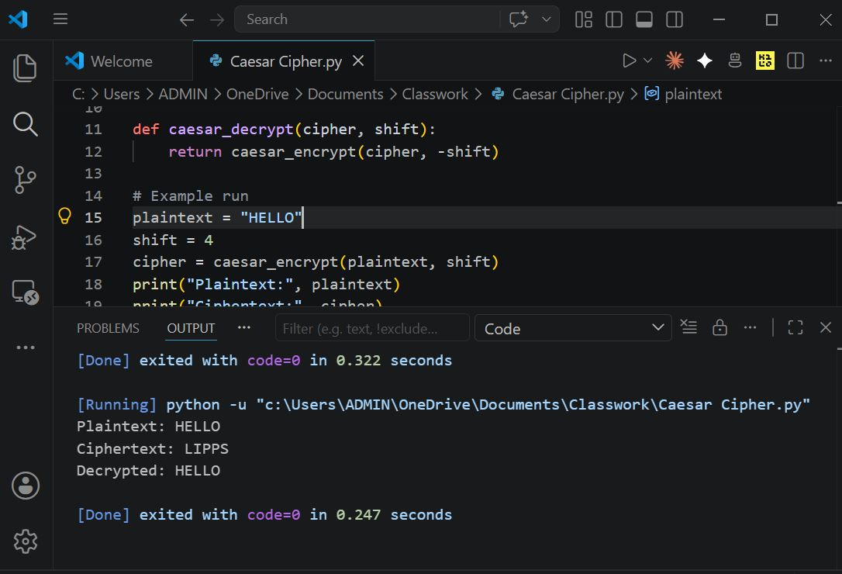

Fig 2: Vigenère Cipher Encryption Process

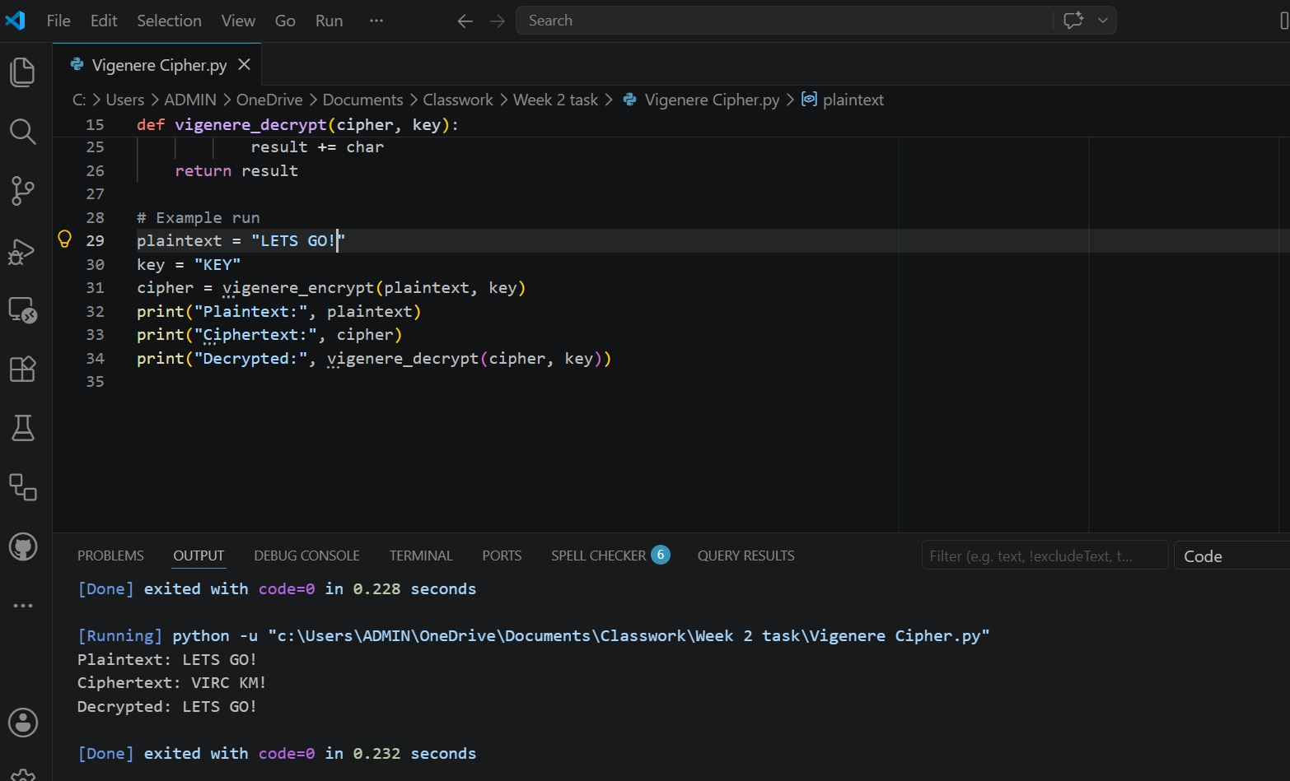

Fig 3: Encryption and Decryption Output

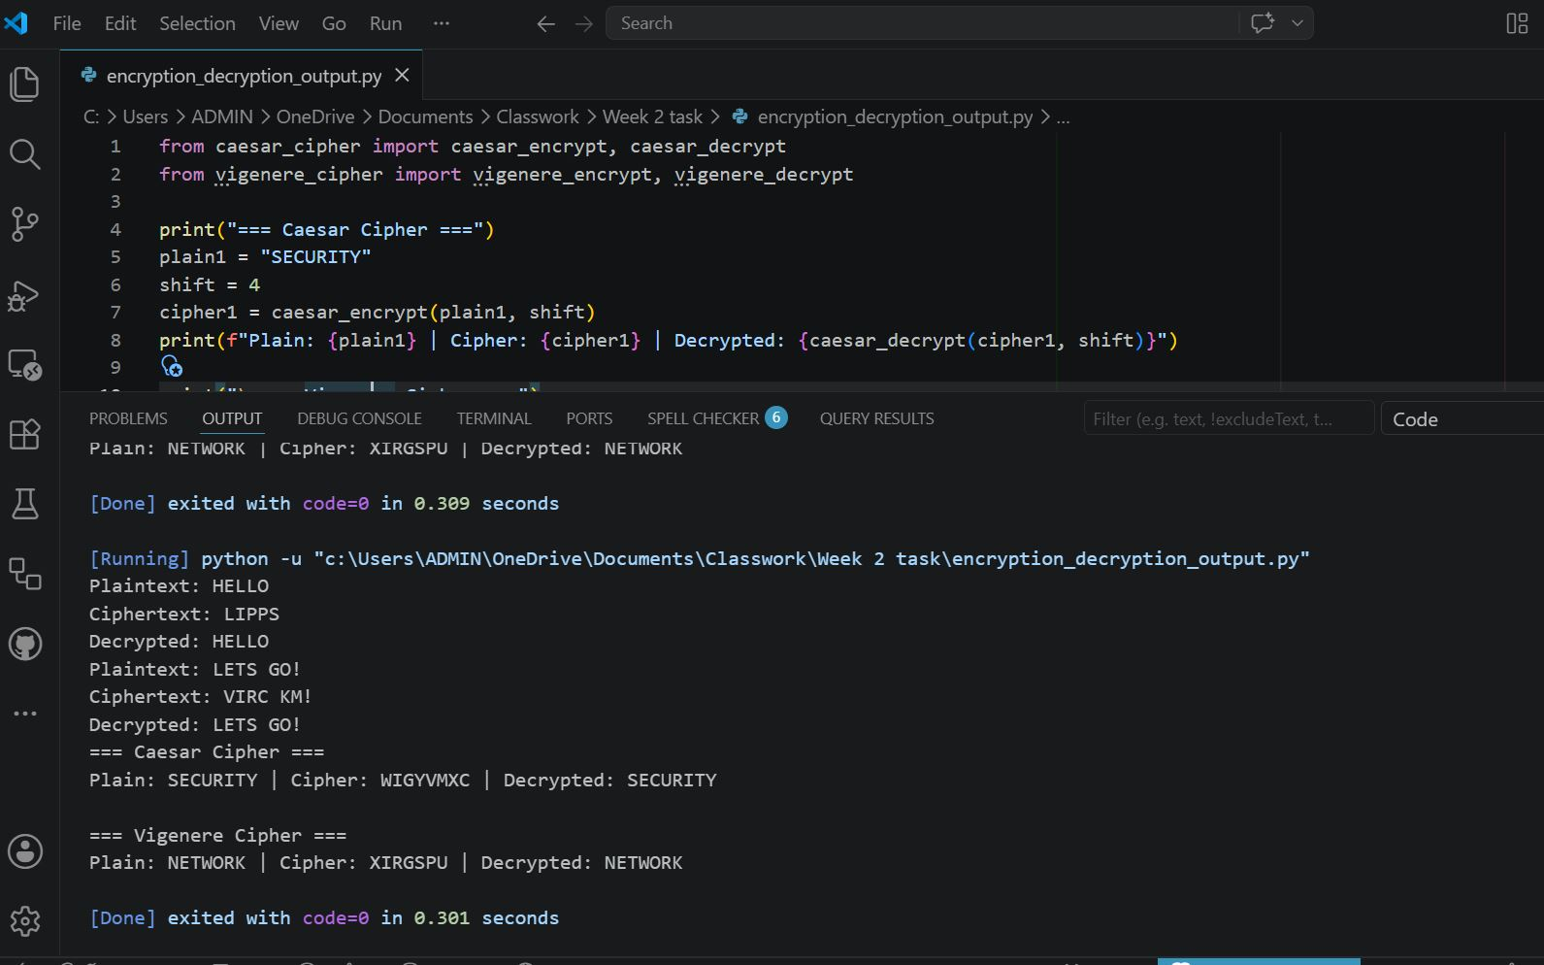

Fig 4: User Input Validation Interface

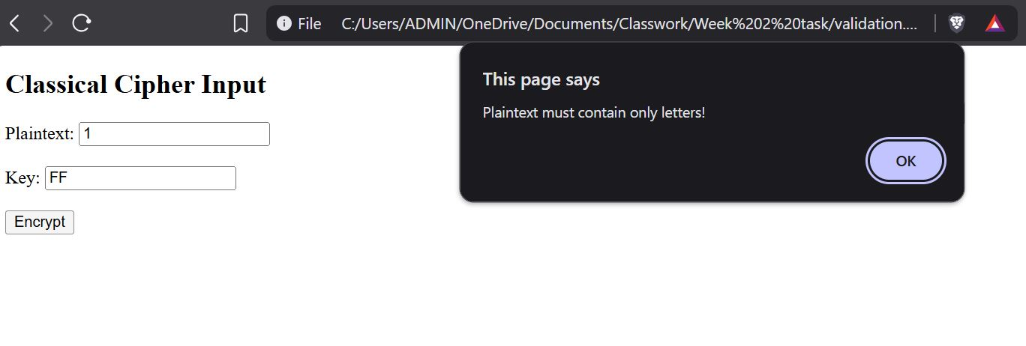

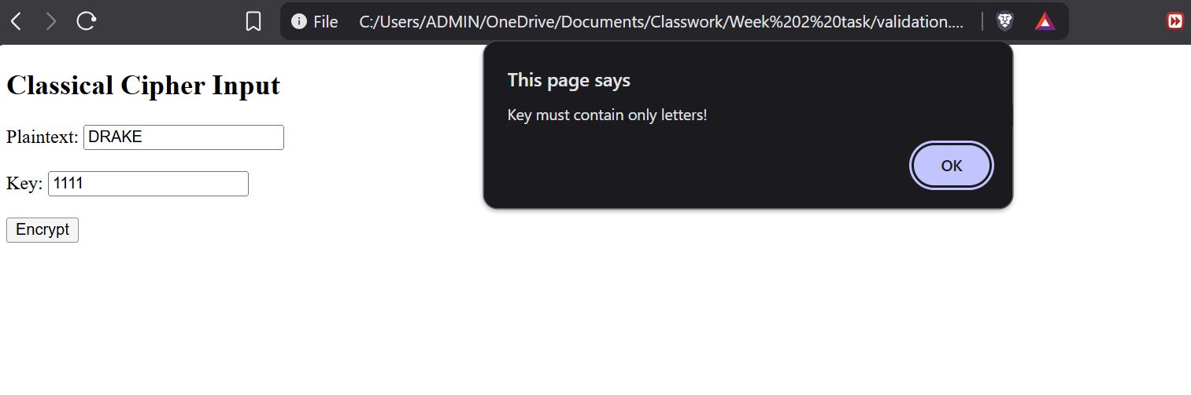

Fig 5: Cipher Testing Results

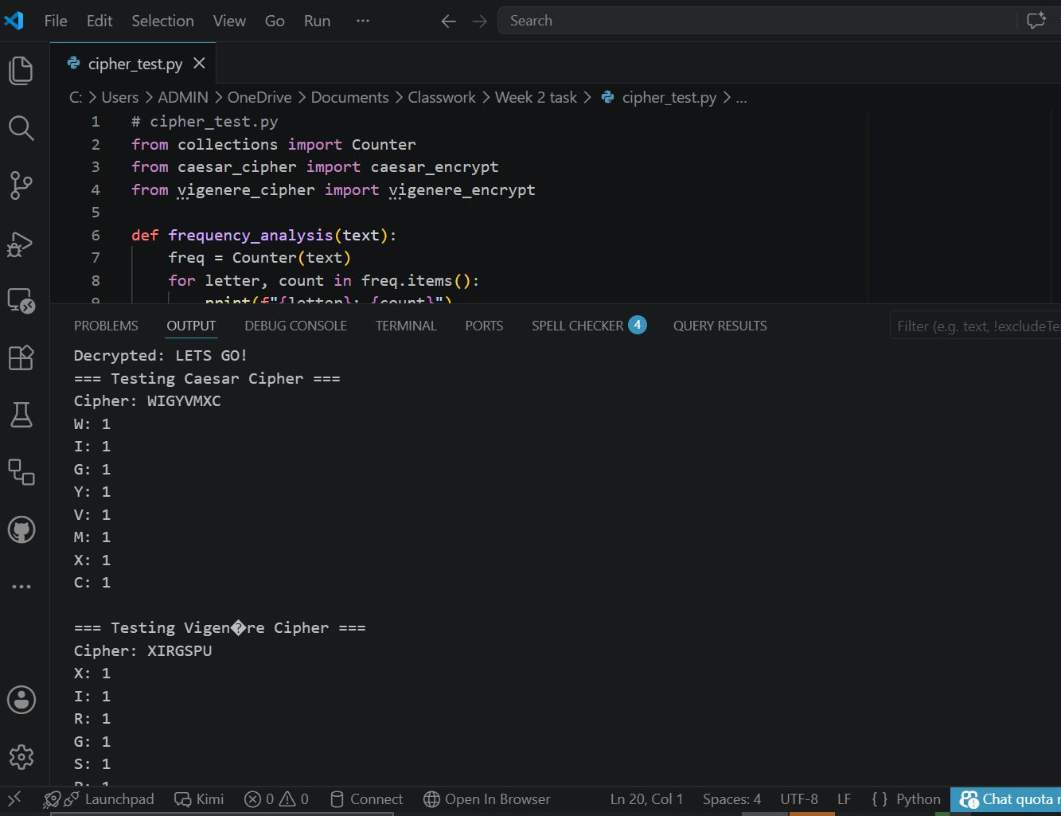

Student Reflection
The Vigenère Cipher implementation demonstrated how polyalphabetic encryption improves security compared to Caesar Cipher. Screenshots confirmed successful encryption and decryption using different keys. Keys are essential in defining shifts, the workflow involves input–process–output, and weaknesses like frequency analysis highlight why modern cryptography is necessary

